**Competitive Influence on Customer Churn: Strategy Blueprint for Management & Consulting**

**🧭 Executive Summary**

Customer churn—especially among low-tenure, low-spend segments—is accelerating due to weak onboarding, aggressive competitor pricing, and inconsistent support.

To counter this, we recommend a **retention-first strategy** that stabilizes the core customer base, protects margins through smart tiering, and expands cautiously into value-sensitive markets—all while preserving a premium brand perception.

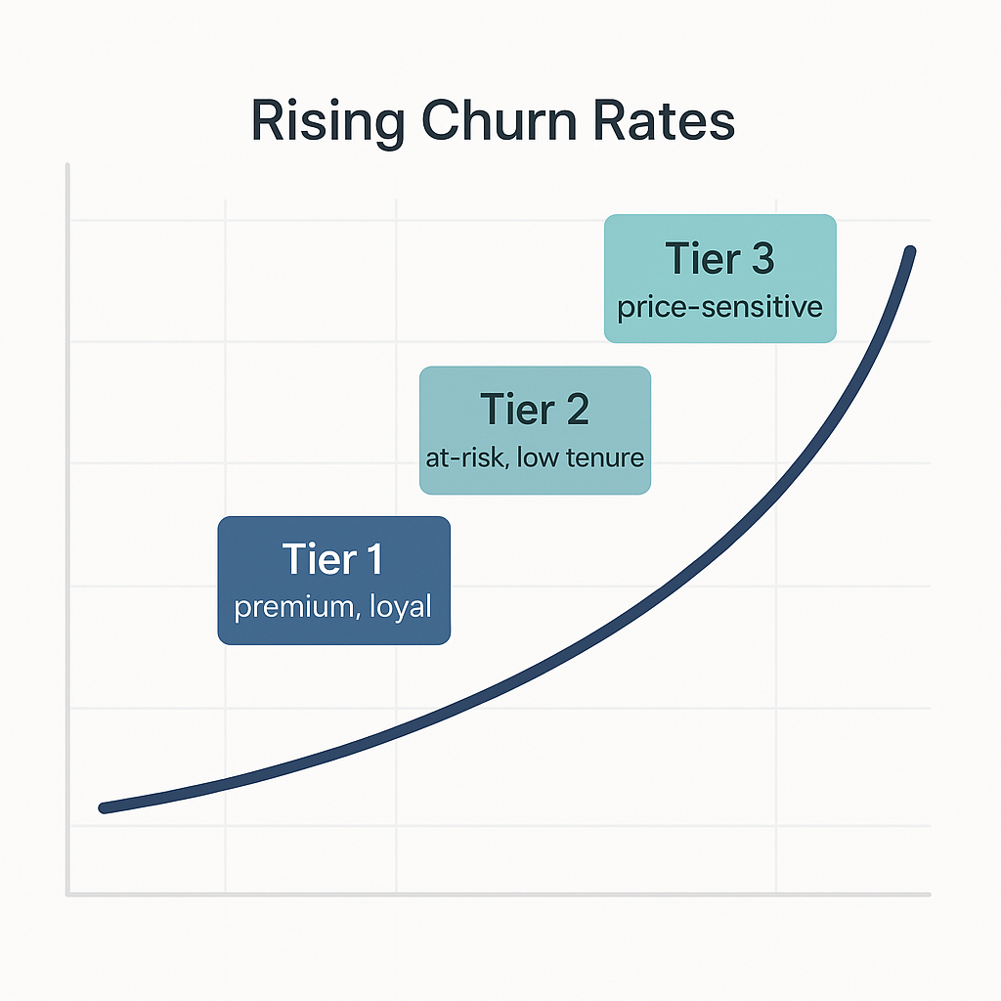

**🔑 Strategic Pillars**

**1. Tiered Retention Framework**

Segment customers into:

* **Tier 1**: High-value, loyal
* **Tier 2**: At-risk, early tenure
* **Tier 3**: Price-sensitive and transient

**Why it matters**: Enables customized retention, cost-efficient support, and relevant offers.

**Actions**:

* **Tier 1**: Focus on upsell and cross-sell bundles
* **Tier 2**: Provide concierge onboarding and proactive support
* **Tier 3**: Offer digital-first engagement with tailored pricing

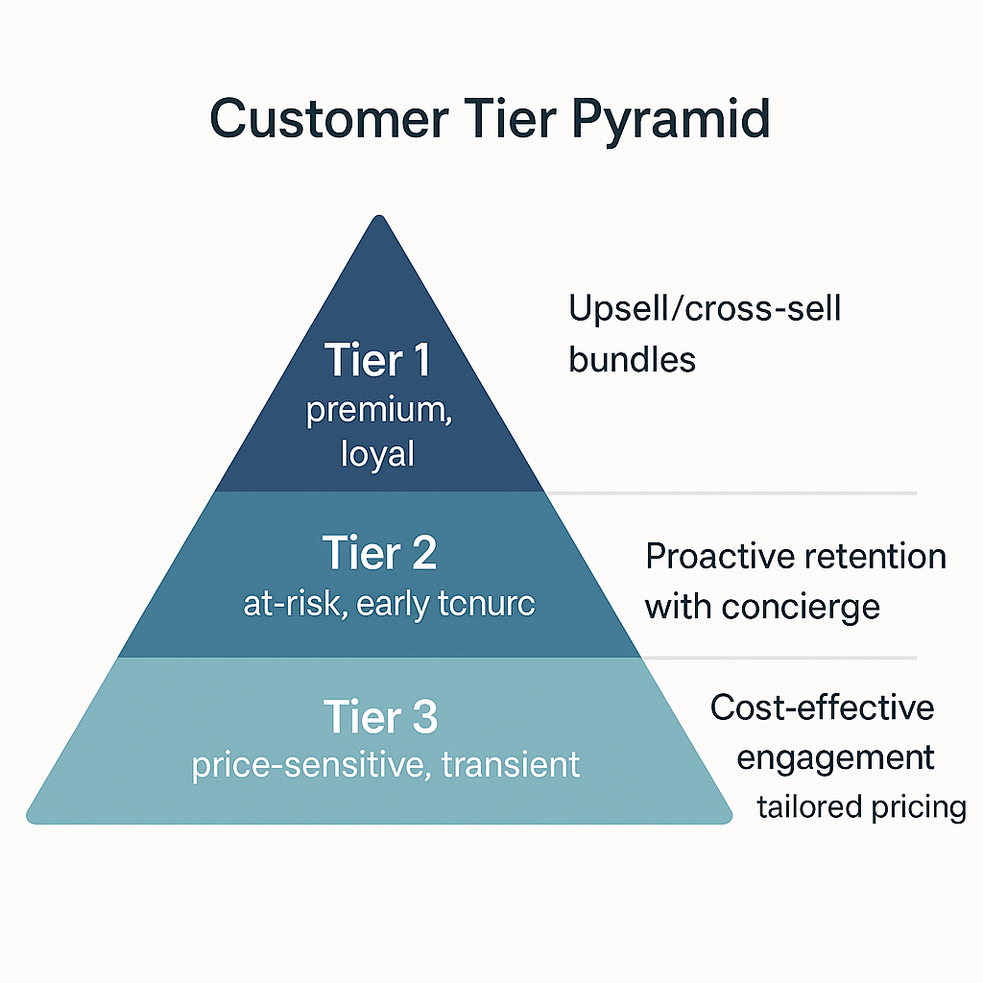

**2. Churn Risk as a Core KPI**

Churn probability should be a **standard performance metric** across departments.

**Why it matters**: Embeds accountability in cross-functional teams.

**Actions**:

* Display churn risk on executive dashboards
* Tie NPS + churn data to performance evaluations

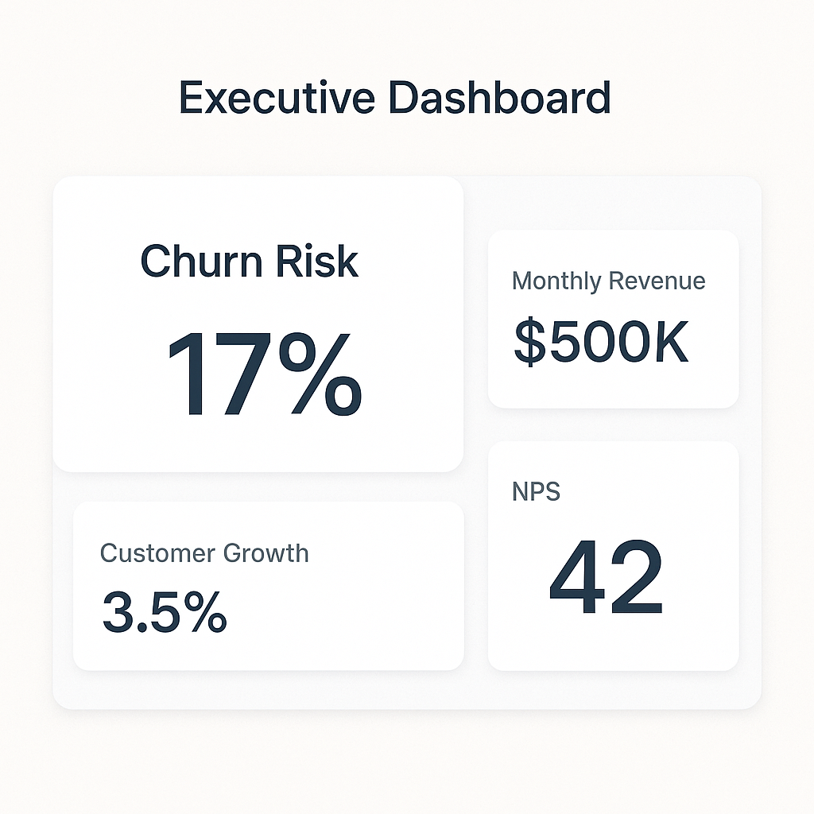

**3. Competitor Intelligence–Driven Product Strategy**

Turn fragmented competitor insights into a proactive response system.

**Why it matters**: Keeps pricing and offerings defensible and agile.

**Actions**:

* Set pricing triggers based on competitor moves
* Create “shadow bundles” for rapid rollout

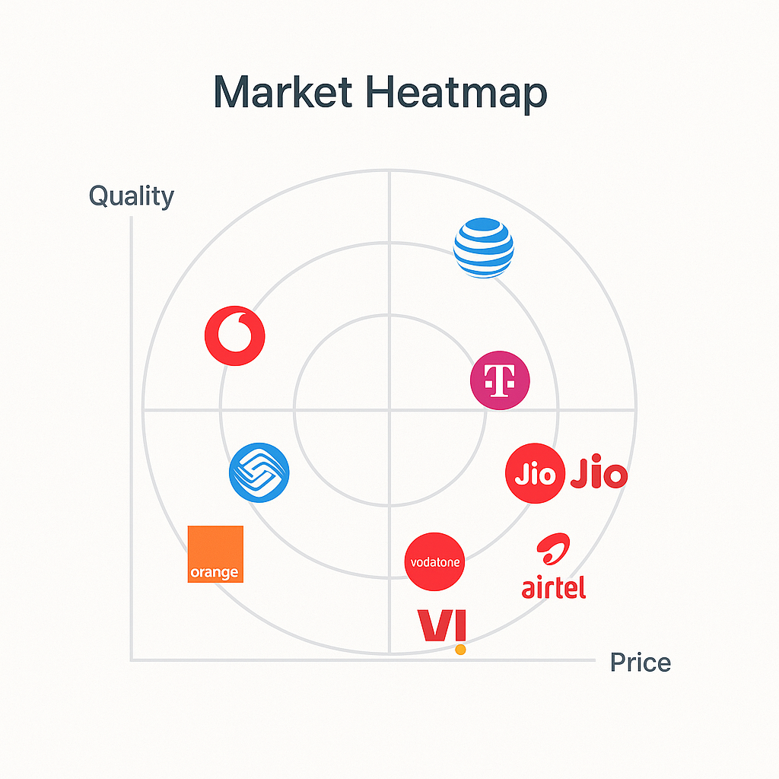

**4. Loyalty That Protects Margin**

Introduce **personalized loyalty incentives** based on tenure and spend—not blanket discounts.

**Why it matters**: Retains value customers without eroding profit.

**Actions**:

* Implement a smart loyalty engine
* Offer longer-term contracts for customers with churn risk but high potential

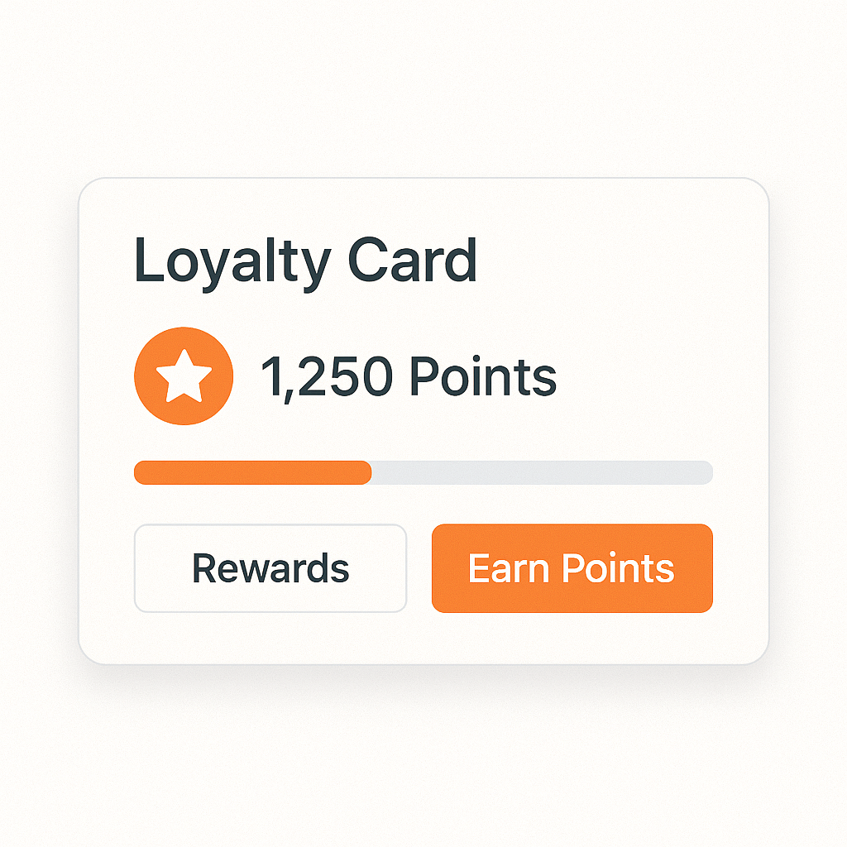

**5. Humanized Omnichannel Experience**

Unify the customer experience across all touchpoints—chat, voice, and app.

**Why it matters**: Customers leave not just for price, but for poor or impersonal service.

**Actions**:

* Sync CRM systems for full-context support
* Use AI for proactive issue resolution



**6. Soft Market Expansion**

Test price-sensitive markets through **controlled pilots**, not full-scale brand rollout.

**Why it matters**: Learn price elasticity and behavior without risking brand equity.

**Actions**:

* Launch sub-branded beta offerings
* Use insights to guide broader strategy

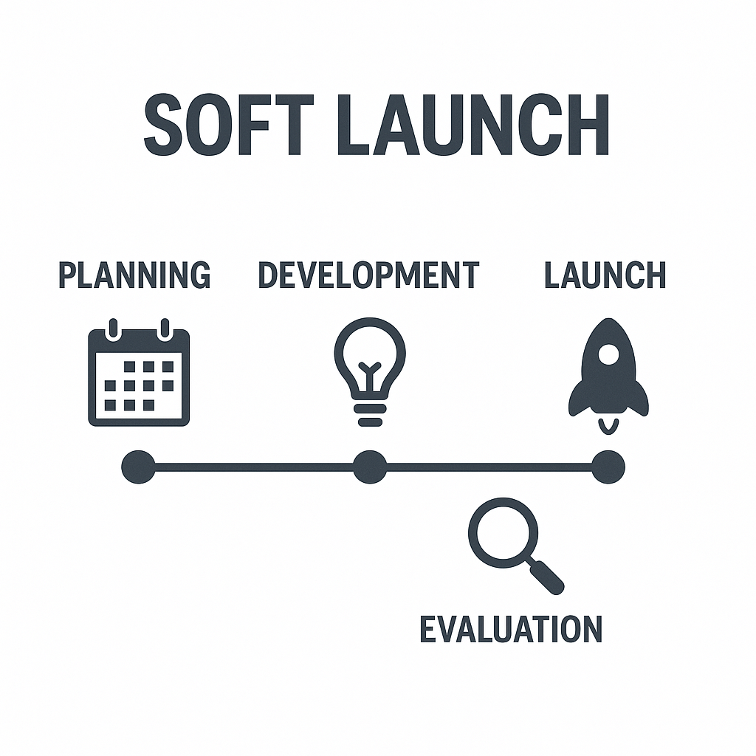

**📊 Strategic KPIs to Track**

| **Category** | **Key Metric** | **Owner** |
| --- | --- | --- |
| Customer Retention | % Churn Reduction by Tier | Head of Customer Success |
| Margin Protection | Net Margin per Retained Customer | CFO |
| Competitive Agility | Time to Launch Counter-Offers | Product Strategy Lead |
| Loyalty Program Impact | LTV Uplift in Tier 2 Customers | Marketing Director |
| Onboarding Effectiveness | Churn Rate Within First 90 Days | Operations Lead |

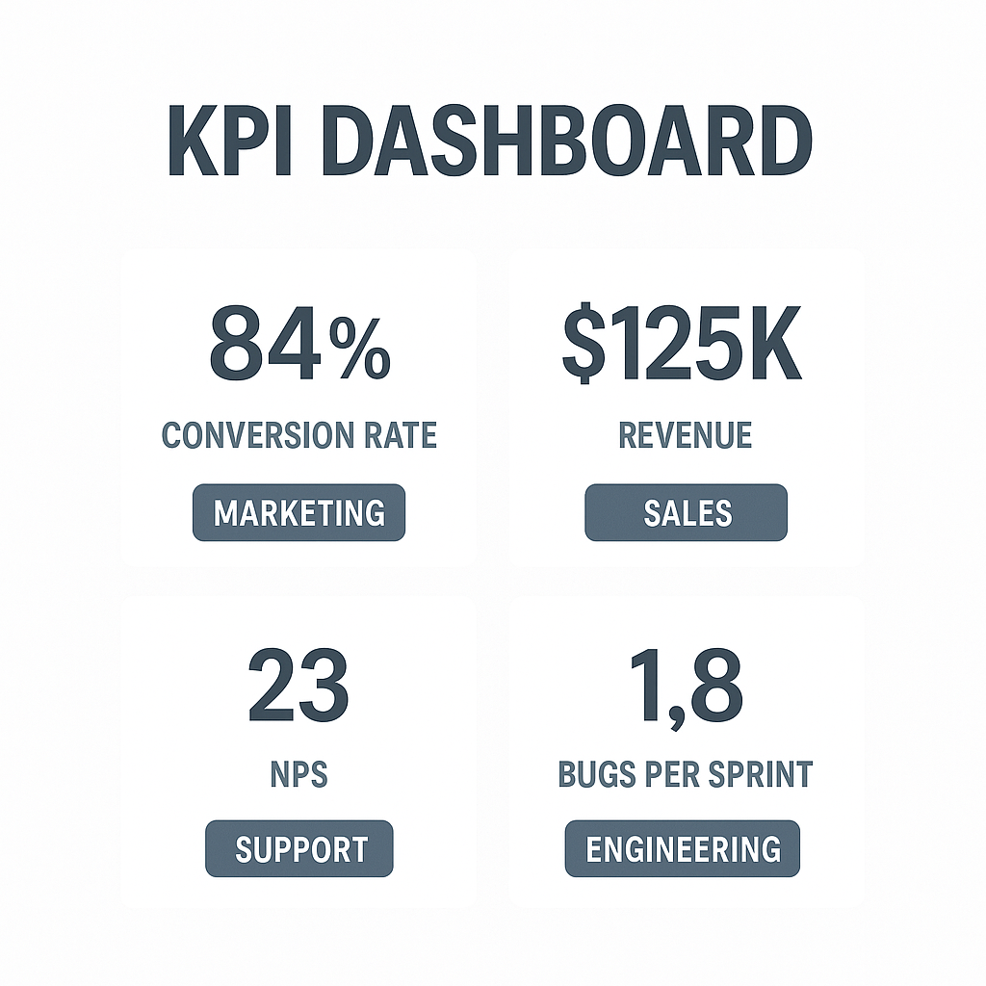

**✅ Strategic Alignment Matrix**

| **Goal** | **Enabling Actions** |
| --- | --- |
| Grow via Retention | Tiered churn model + smart loyalty engine |
| Protect Profitability | Targeted incentives + margin-aware segmentation |
| Expand Strategically | Sub-branded pilot programs |
| Drive Accountability | Cross-team KPIs + churn ownership |

